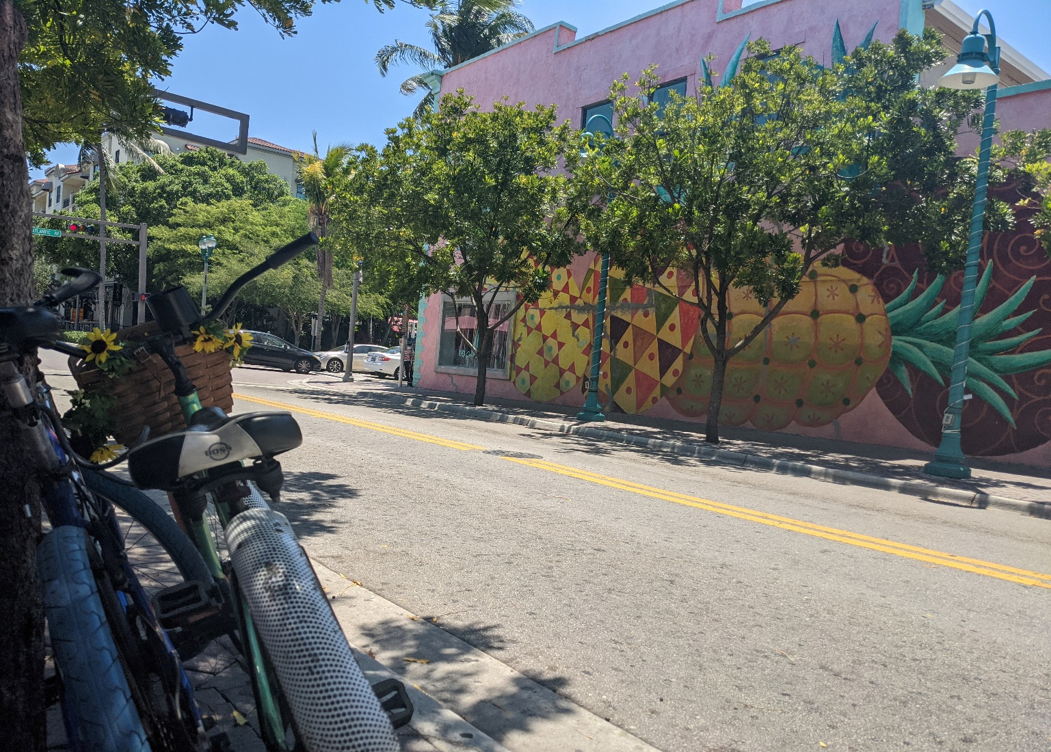
WALK + BIKE
DELRAY BEACH
Survey, interactive comment map, meeting information, and more information available at the Project Website: www.walkbikedelraybeach.com
The City of Delray Beach requests the input and participation of residents and visitors for the Pedestrian and Bicycle Master Plan. The City of Delray Beach will also be hosting a number of events to gather input for the overall project vision, goals, and objectives, and draw their projects on the map that they would like the City to implement.
For those who can’t attend any of these events, a survey, interactive comment map, and additional information is available at the project website. Fill out the contact us form at the bottom of the page to be kept up to date with project announcements.
An overarching project goal is to integrate walking and bicycling into the City’s overall mobility strategy and as an option for everyday lives. The result of this plan will be a blueprint for the City of Delray Beach to create a safe, comfortable, and convenient network of sidewalks, bicycle lanes, and trails throughout the city as well as provide connections to the regional non-motorized transportation and transit network.
Event Schedule
March 24 – Open House
Veteran’s Park, 802 NE 1st Street, Delray Beach
4:00 PM – 6:00 PM
March 26 – Bicycle Safety Event and Ride (Rain or Shine)
Old School Square Great Lawn, Across from Ramen Lab Eatery. Free parking available by riding your bicycle, or vehicle parking at Old School Square Parking Garage until 4 PM.
9:00 AM: Bicycle Safety Event with Delray Beach Police Department and the Palm Beach Transportation Planning Agency
9:30 AM: Bicycle Ride to the Beach Pavilion, Return from the Beach Pavilion at 10 AM
10:00 AM: Input opportunities at the Delray Beach Community Resource Fair
March 31 – Open House
Delray Beach Golf Club, 2200 Highland Ave Unit A, Delray Beach
4:00 PM – 6:00 PM

WALK + BIKE
DELRAY BEACH
Public Meetings, Both at 4:00 PM to 6:00PM
March 24th, Veteran’s Park, 802 NE 1st Street
March 31st, Delray Beach Golf Club, 2200 Highland Ave Unit A
More information available at the
Project Website: www.walkbikedelraybeach.com
WALK + BIKE
DELRAY BEACH
Bicycle Safety Event and Ride (Rain or Shine)
Old School Square Great Lawn, Across from Ramen Lab Eatery
9:00 AM Bicycle Safety Discussion and Presentation
9:30 AM Bicycle Ride to the Beach Pavilion and Back
10:00 Delray Beach Community Resource Fair

